1. Write a program to Print Fibonacci Series using recursion.

**F(n) = F(n-1) + F(n-2)**

**TIME COMPLEXITY: O(2n)**

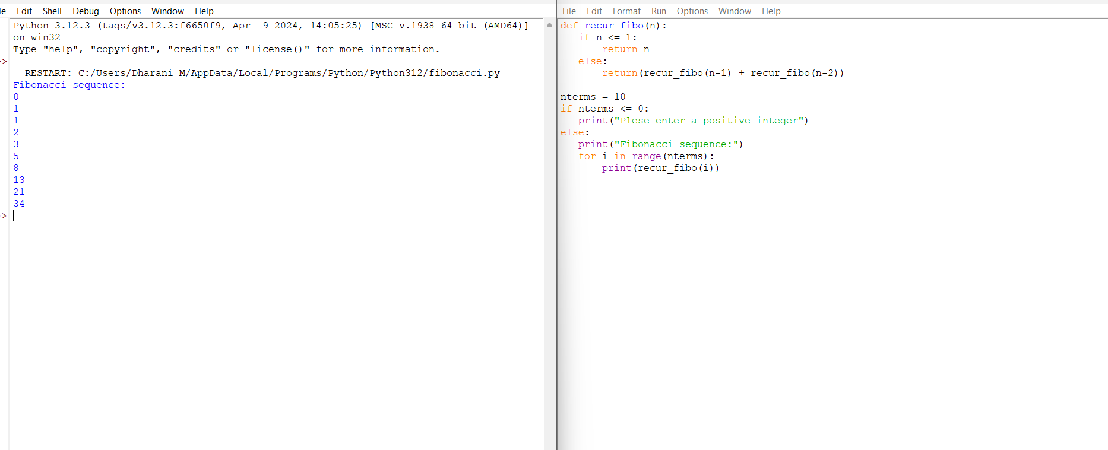

1. Write a program to check the given no is Armstrong or not using recursive function.

**TIME COMPLEXITY:** O(1).

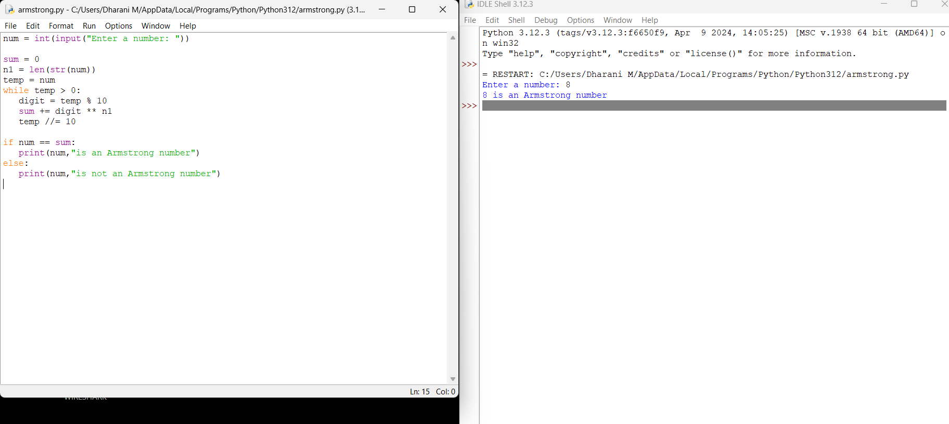

1. Write a program to find the GCD of two numbers using recursive factorization

**TIME COMPLEXITY:** O(log(min(a,b))),

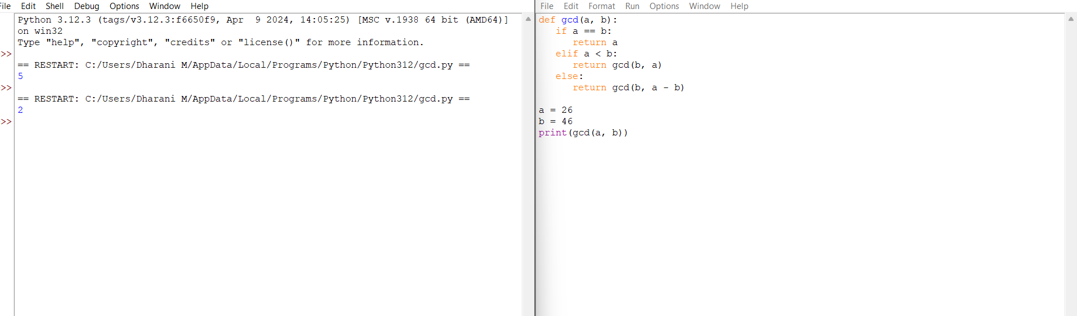

1. Write a program to get the largest element of an array.

**TIME COMPLEXITY:** O(N),

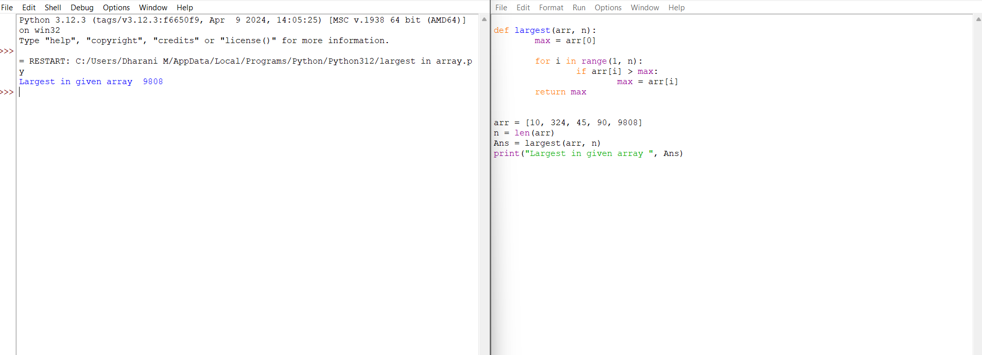

1. Write a program to find the Factorial of a number using recursion.

**TIME COMPLEXITY:** : **O(N)**

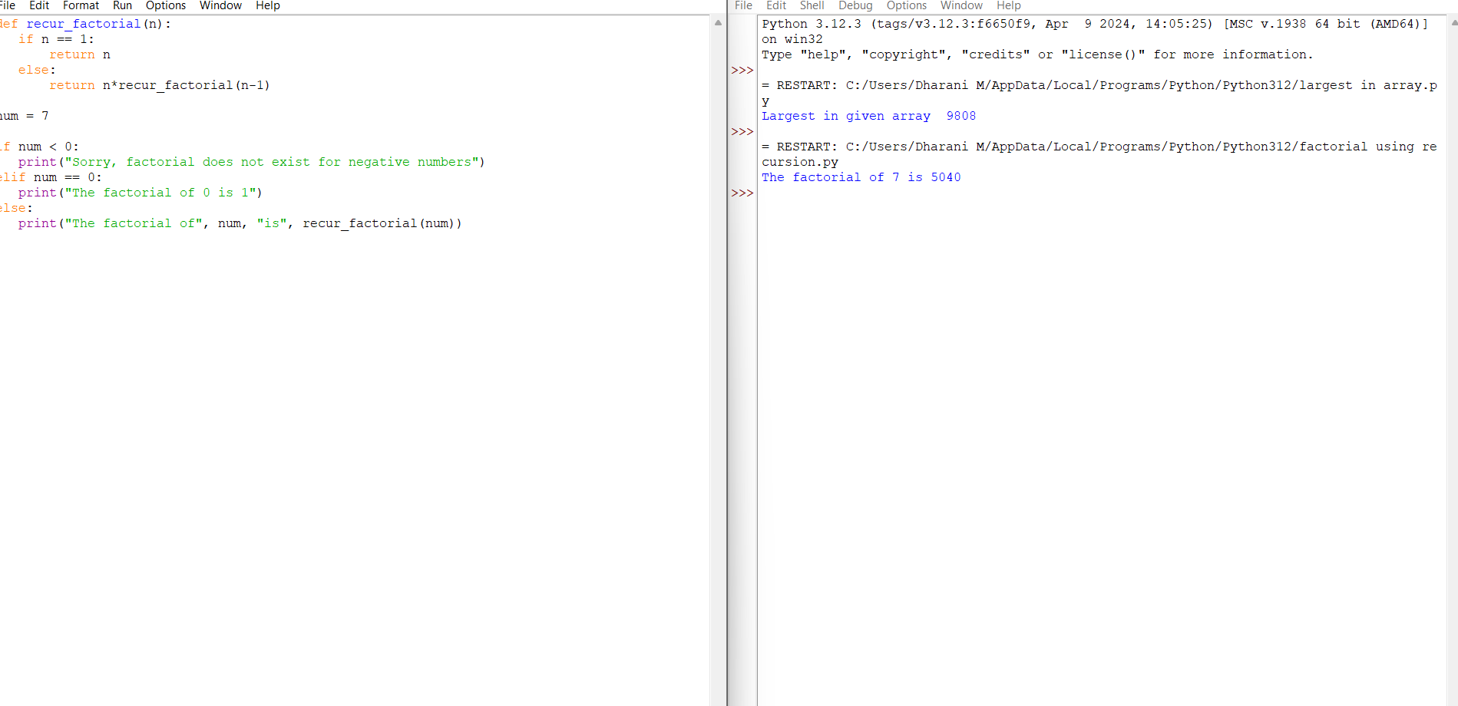

1. Write a program for to copy one string to another using recursion

**TIME COMPLEXITY:** O(m)

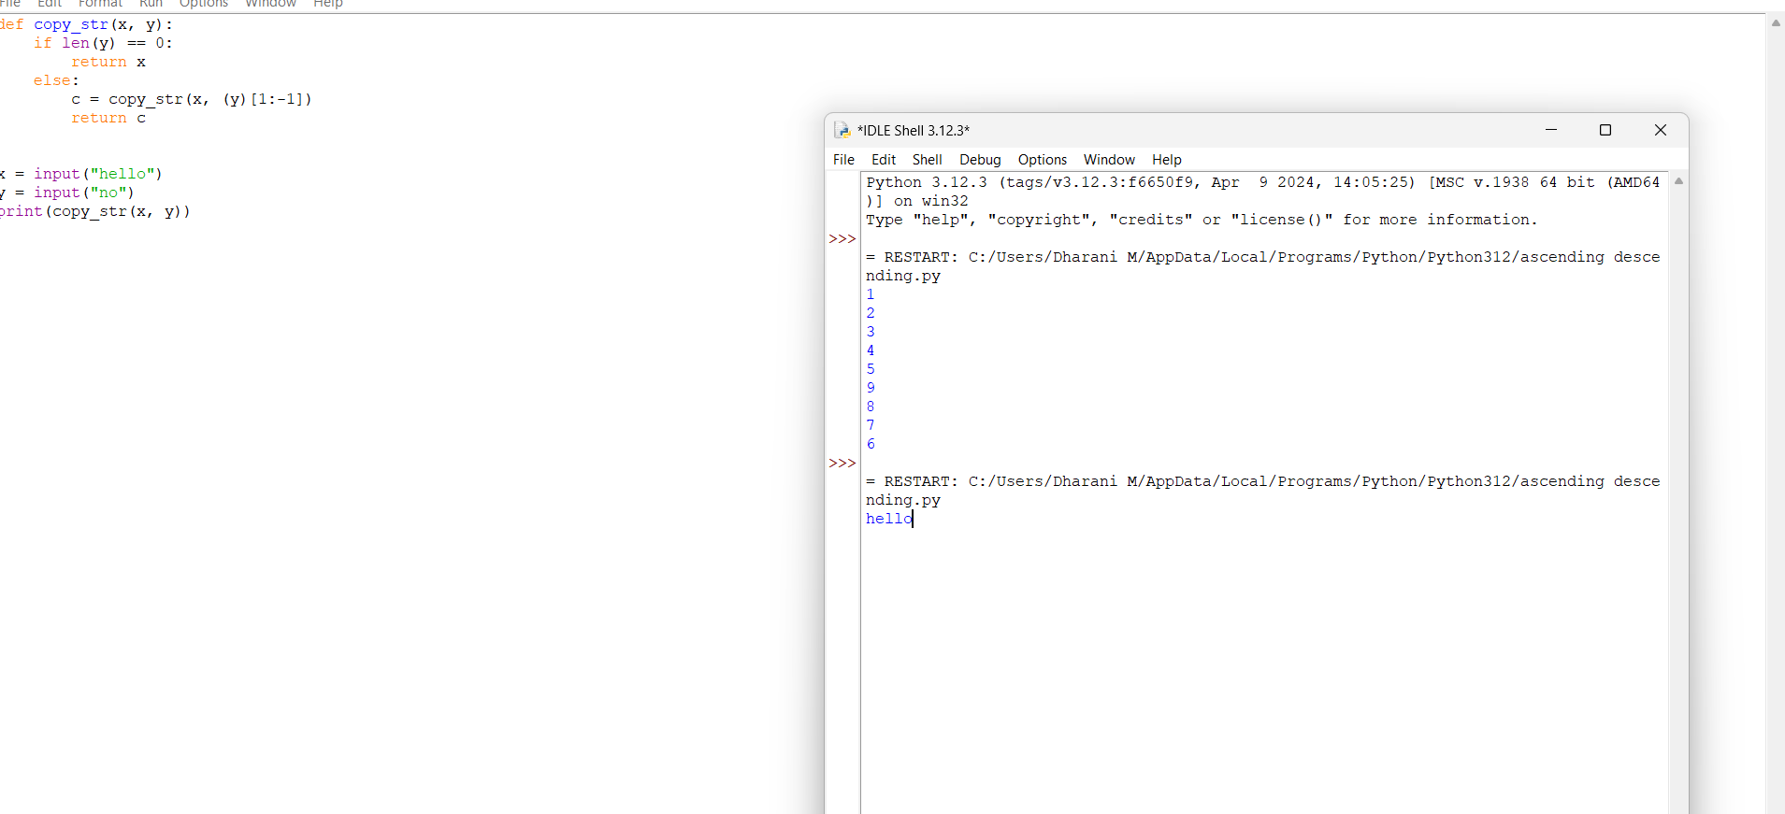

7. Write a program to print the reverse of a string using recursion

**TIME COMPLEXITY:** O(n)

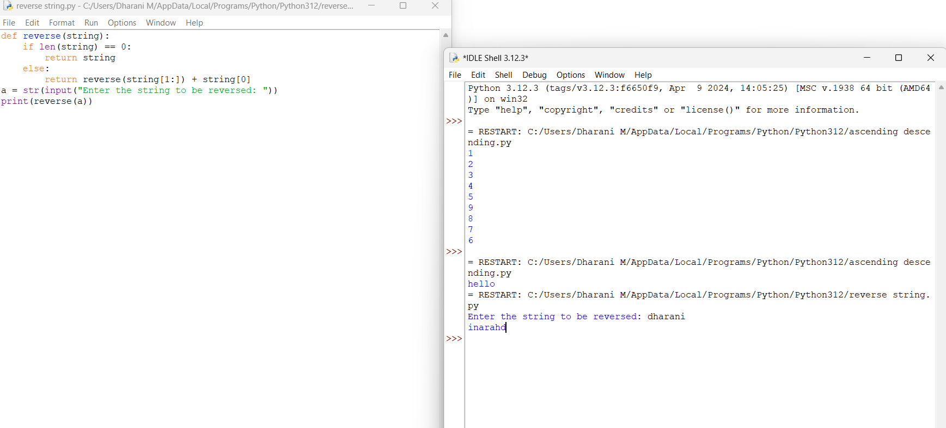

8. Write a program to generate all the prime numbers using recursion

**TIME COMPLEXITY:** O(√N).

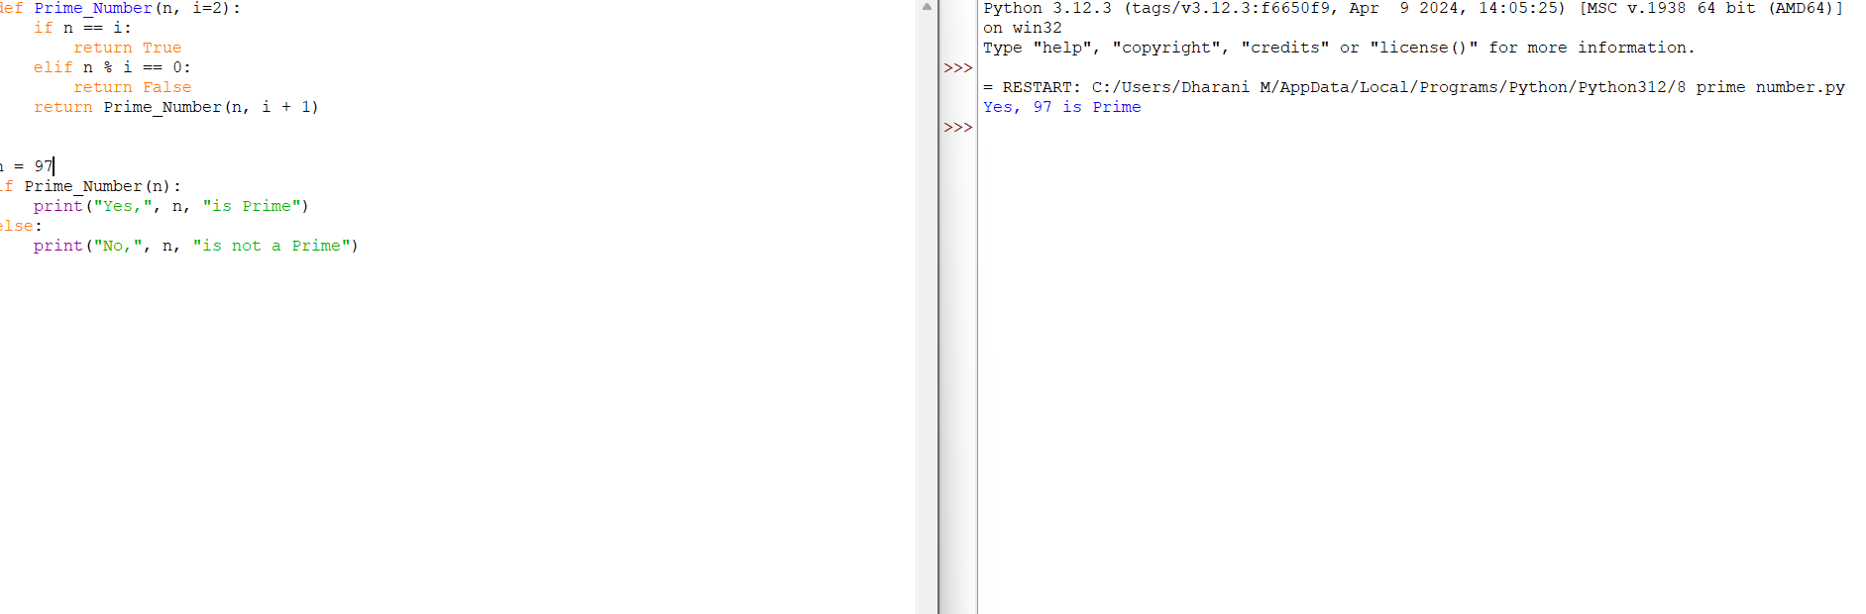

9. Write a program to check a number is a prime number or not using recursion.

**TIME COMPLEXITY:** O(n)

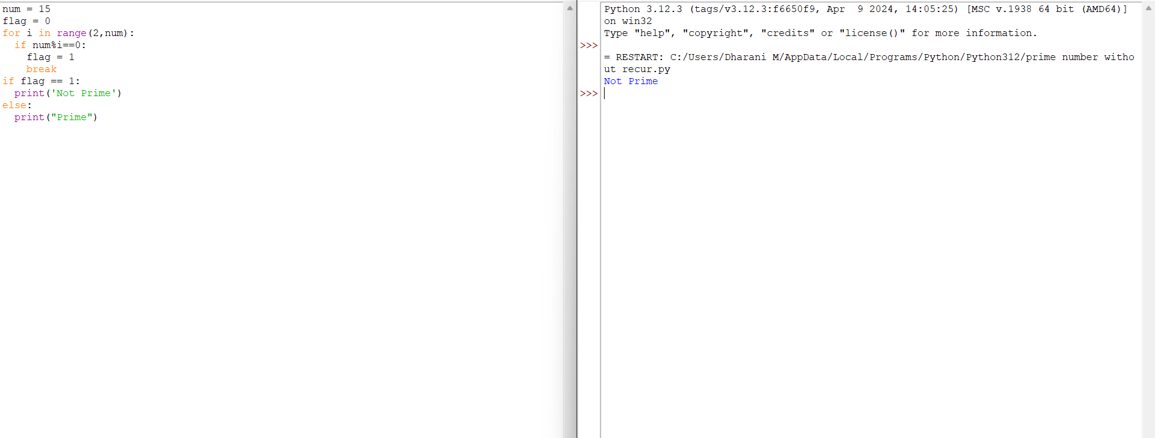

10.Write a program for to check whether a given String is Palindrome or not using recursion

**TIME COMPLEXITY:**O(n)

